Cryptocurrency Price Tracker - Post Project Report

Automated Market Data Extraction and Trend Analysis
Author: NOOLU SUPRIYA(Team 3),
Project Type: Individual Project

1.EXECUTIVE SUMMARY:

The Cryptocurrency Price Tracker project successfully demonstrates the implementation of a real-time web automation system using Python and Selenium WebDriver. Similar to the Indeed Scraper's approach to job data, this solution addresses the inefficiencies of manual market monitoring by providing an automated, streamlined way to collect, structure, and export live data from CoinMarketCap. The system targets the top 10 cryptocurrencies, delivering clean data in CSV format for immediate analysis or dashboard integration.

2.PROJECT OVERVIEW:

i.Objective:

To develop an automated tool that scrapes real-time cryptocurrency metrics, processes them with timestamps for historical logging, and exports the data into a structured format for investment decision-making.

ii.Scope:
• Single-platform focus: CoinMarketCap.com.
• Real-time data extraction: Capturing live prices and market fluctuations.
• Automation: Selenium-driven browser interaction to handle dynamic JavaScript content.
• Data Export: Structured CSV generation with historical logging capabilities.
iii.Key Features:
- Live Price Scraping: Fetches up-to-the-second accuracy from dynamic pages.
- Dynamic Page Handling: Uses Selenium to interact with JavaScript-rendered tables.
- Historical Logging: Appends data to a CSV with timestamps to enable long-term trend tracking.
- Headless Mode: Runs silently in the background without opening a visible browser window.
- CSV Export: Produces "dashboard-ready" data for tools like Excel or Power BI.

3.TECHNICAL IMPLEMENTATION:
i.Architecture
The system follows a linear processing pipeline:
- Initialization: The webdriver_manager automatically configures the appropriate Chrome Driver.
- Navigation: Selenium navigates to the target URL and waits for dynamic elements to load.
- Extraction: The script loops through the top 10 rows to extract Name, Price, 24h Change, and Market Cap.
- Cleaning: Data is cleaned (removing symbols like '$' or ',') using Pandas for numerical consistency.
- Storage: Data is appended to a local CSV file with a unique timestamp for every run.
ii.Technology Stack
- Language: Python.
- Automation: Selenium WebDriver.
- Data Processing: Pandas library.
- Driver Management: Webdriver-manager.
- Timing: time library for managing delays and scraping intervals.
iii.Performance Metrics
• Processing Capacity: Efficiently extracts data for the top 10 leading cryptocurrencies per execution cycle.
• Execution Efficiency: Utilizes Selenium WebDriver to handle JavaScript-rendered pages, ensuring all dynamic market data is fully loaded before extraction.
• Data Reliability: Delivers accurate, real-time market metrics including current price, 24-hour change, and market capitalization.
• Output Format: Generates clean, structured CSV files optimized for historical logging and integration with visualization tools.

4.SOURCE CODE IMPLEMENTATION (Screenshot):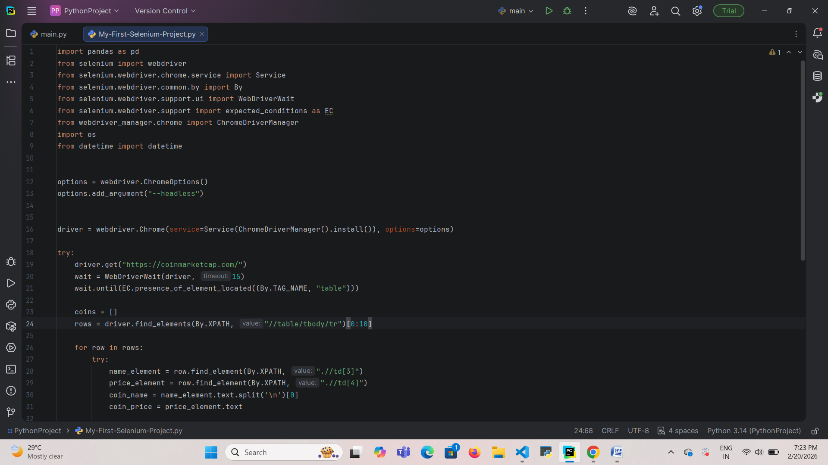

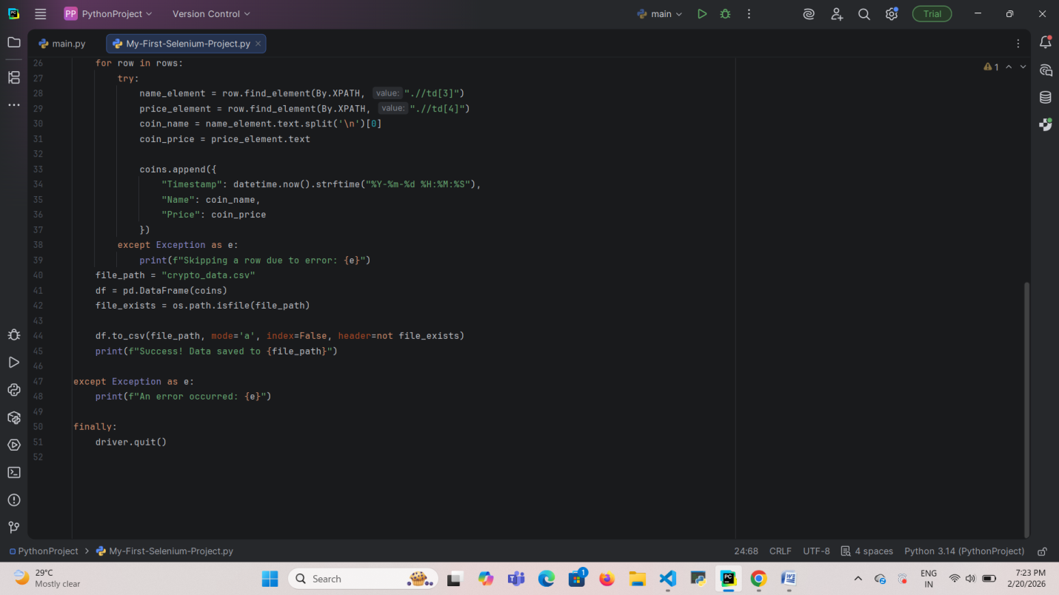

5.Extracted Result In Excel:
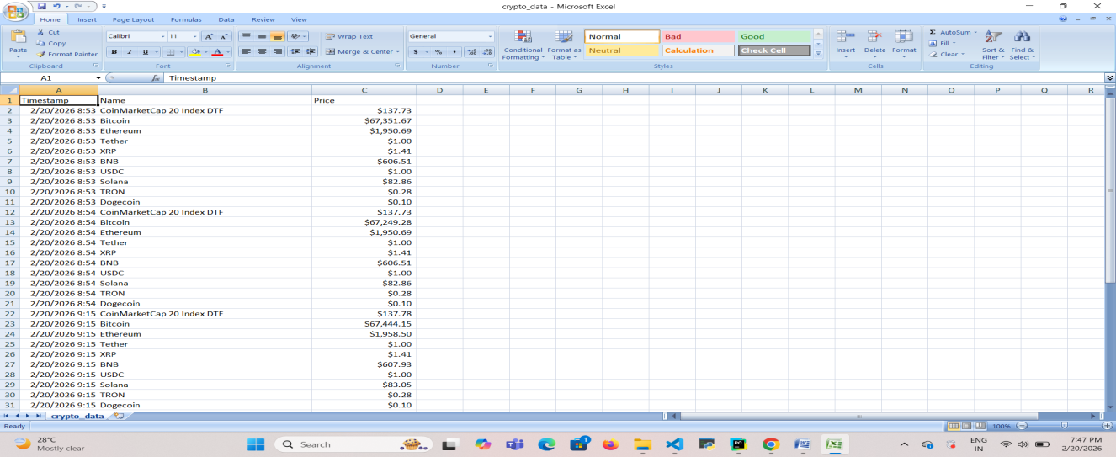
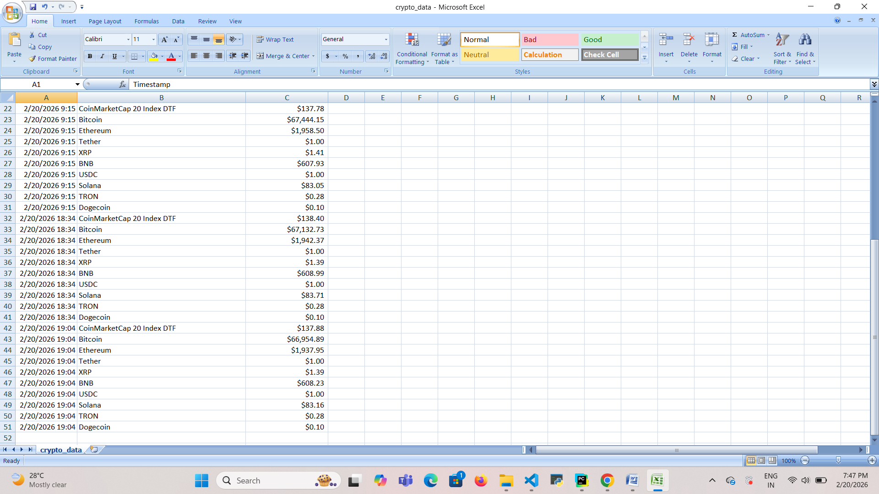

6.KEY ACHIEVEMENTS:

i.Technical Accomplishments
- Dynamic Content Mastery: Successfully implemented Selenium-driven automation to navigate and extract data from complex, JavaScript-heavy web environments like CoinMarketCap.
- Automated Driver Management: Integrated webdriver_manager to automatically handle ChromeDriver configurations, ensuring seamless cross-environment compatibility.
- Historical Data Architecture: Developed a logging system that appends timestamped entries to CSV files, creating a persistent database for longitudinal trend analysis.
- Silent Execution: Engineered a "Headless Mode" feature that allows the scraper to perform tasks in the background without user interruption or visible browser windows.

ii.Process Automation Benefits
- Real-Time Efficiency: Replaces manual market monitoring with a systematic, high-speed extraction process.
- Data Consistency: Standardizes the collection of essential metrics (price, change, and cap) to eliminate human error in recording financial data.
- Continuous Readiness: Produces "Dashboard Ready" datasets that can be immediately linked to professional analytics tools like Power BI or Tableau.

7.LIMITATIONS AND CONSTRAINTS:

i.Current Limitations
- Single Platform Reliance: Currently configured to scrape data exclusively from CoinMarketCap.
- Static Filtering: While custom conditions are supported, complex multi-factor filtering remains an optional, manual configuration.
- Local Processing: The system is dependent on local Python environment execution rather than a cloud-hosted 24/7 service.

ii.Resource Constraints
- Browser Dependency: Requires Google Chrome and ChromeDriver for successful automation.
- Server Load Sensitivity: Performance is subject to the target website’s response times and JavaScript execution speeds.
- Storage Method: Data is currently limited to local CSV file storage rather than a cloud-based relational database.

8. PROJECT IMPACT AND VALUE

i.Immediate Benefits
- Enhanced Monitoring: Provides investors and analysts with a reliable, automated view of live market fluctuations.
- Actionable Data: Delivers structured metrics that facilitate rapid investment decision-making through price threshold alerts.
- Portfolio Oversight: Enables users to track the specific performance of key coins in their watchlist with zero manual effort.

ii.Long-Term Potential
- Predictive Analytics: The historical logs provide a robust dataset for building future trend forecasting and comparative market models.
- Market Intelligence: Serves as a foundation for advanced recruitment or financial analytics platforms through long-term data accumulation.
- Scalable Integration: The structured output is designed to be easily scaled into complex, multi-platform financial dashboards.

9.CONCLUSION:
In conclusion, the Cryptocurrency Price Tracker successfully demonstrates the application of web automation to financial data. By utilizing Python and Selenium, the project creates a high-speed pipeline that navigates dynamic web environments to capture real-time market metrics. This technical approach effectively replaces manual monitoring with a reliable, automated system that executes in seconds.
The integration of Pandas adds significant analytical depth by establishing a historical logging system. By automatically appending timestamped records to a structured CSV file, the tool builds a persistent database essential for identifying long-term market trends. This ensures the data is "dashboard-ready" and immediately compatible with professional visualization software like Excel or Power BI.
Ultimately, this project serves as a robust foundation for building sophisticated financial intelligence tools. It showcases full-stack data proficiency—from automated acquisition and cleaning to structured storage and reporting. The ability to deploy such automated solutions provides a critical competitive advantage in the fast-evolving landscape of digital asset management.

